Testing the Power Amplification Board

Servicing a SuperDARN Transceiver  
Step 9

Content

1. Introduction 3

2. Instructions 3

3. Shortcut 5

4. Conclusion 6

# Introduction

This document provides work instructions for testing the Power Amplification Board in a SuperDARN transceiver box. Before attempting to implement these instructions, be sure to complete all the preceding steps in the procedure for Servicing a SuperDARN Transceiver.

# Instructions

Following are the step-by-step instructions for testing the Power Amplification Board. In the case of unforeseen problems occurring, apply electronic fault-finding techniques.

1. Connect the Tx Env output of the Radar Lab 2.0 to the pulse modulation input on the back of the AWG/signal generator (Modulation In) to generate the RF pulses; this will be used later.
2. Connect the Tx/Rx signal from the Radar Lab to the STC in the FGPA header on the Power Distribution Board.
3. Connect 3.3 V from the bench PSU to the 50 V enable and the HV supply enable to the FPGA header on the Power Distribution board (via the STC). This should already be done in pervious steps.
4. Remove the 50 V supply leads from the capacitor board and replace with 30 V from the bench PSU. Limit the current initially to 1 A. (Notice your supply to the PWRAMP only has positive, so make sure to only attach positive and use a clip to attach negative to the casing.)
5. Connect the Power Amplification Board to the PDB with the correct phoenix connectors.
6. Switch on Radar Lab 2.0. This should already be done in pervious steps.
7. The next step (9) can be skipped if you are NOT installing a NEW PWRAMP.
8. Only do this step if you are installing a **NEW** Power Amp:
   1. Turn all potentiometers anti-clockwise all the way so that there is no bias on the gates of the MOSFETs.
9. Perform the *auto-balance* function of the current probe.
   1. Ensure that the probe is in a closed/locked state!
   2. Output of the scope on the Tx/Rx channel should be set to 1 MΩ.

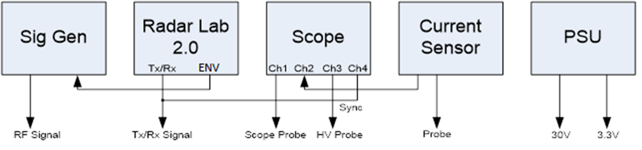

Figure 1. Setup of test equipment.

1. Disconnect the HPSW from the Power Amp (via RF connector).
2. Terminate the output of the Power Amp (**RF_OUT** RF connector).
3. Switch on the transceiver box (mains) and front panel (15 V) – NOT YET THE 30 V PSU SUPPLY!
4. Check that the Tx/Rx signal is present on **P1** – on the Power Amp.
5. Check that **P12** is around 9.8 V using the DMM.
6. This step is not normally done, because it makes breaking the connector easier and readings are not always correct. However, it can be handy for fault-finding:
   1. Remove the thermistor from **P14** and **P12** should increase by about 20 mV. This shows that the thermal compensation is working. Plug the thermistor back in.
7. Check that **P10** is a switched version of **P1** – A bigger waveform by around ±10 V with the same timing. See *Figure 2* below.
8. Check that **J3** (the square hole connection) is the inverse of **P10**. Refer to *Figure 2*.

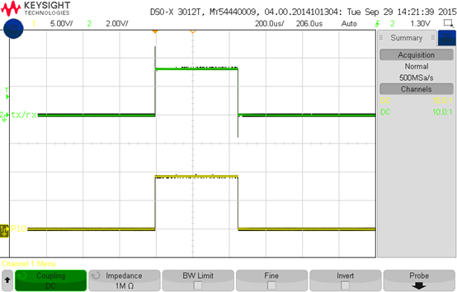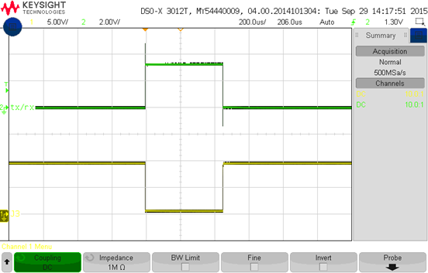

Figure 2. Measured signals on P10 and J3.

1. Check that Pin 5 of **Q1** is a switched 12 V signal. This powers the **HELA10**, see *Figure 3*.
2. Also check that **J5** (Pin 1) is the inverse of Pin 5 on **Q1**, also shown in *Figure 3*.

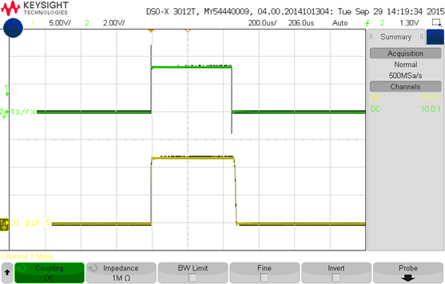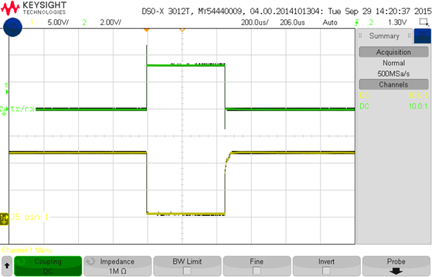

Figure 3. Measured signals on HELA10, Q1.

1. Only do this step if you are installing a **NEW** Power Amp:
   1. Check that all the gates on the MOSFETs are at 0 V. If not, check that the potentiometers are completely turned down.
   2. **NOTE:**  
      The gates are pre-biased using the potentiometers, onto which the drive pulse is added. This makes switching everything faster.
   3. VRF MOSFETs are pre-bias around 3.5 V while MRF MOSFETS are pre-bias at around 3 V. The VRF part is better as it has more gain and a higher breakdown.
2. Switch on the 30 V supply.
3. Attach the other scope probe to the Tx/Rx test point (**P1**).
4. Attach the current probe to the copper wire bridge on the drain leads.
5. Adjust the POT until the current pulse level is 200 mA.
6. For NEW Power Amps only:
   1. The current pulse will at first be asymmetrical, because there are two MOSFETs. Adjust the first one to 100 mA then adjust the second MOSFET’s POT and monitor the current until you get 200 mA current pulses its drain.
   2. Go back to the first drain of the current MOSFET and re-adjust to 200 mA, if necessary.

**NOTE:**Make sure that the scope probe measuring the pre-bias point (Voltage – “Yellow”) is set to 1 MΩ and that the oscilloscope triggers on this channel. Also make sure that the scope probe measuring the current pulse level (Amps – “Blue”) is set to 1 MΩ as well.

1. Repeat the above 2 steps for all 5 pairs.
2. Switch off the 30 V supply and Front Panel.
   1. IF YOU DON’T TURN OFF THE FRONT PANEL POWER YOU RISK SHORTING SOMETHING ON THE FRONT PANEL WITH THE CONNECTOR.
3. Now connect the modulated (as set up in step 1) RF signal to the input (**RF_IN** on the power amp board) with an amplitude of -20 dBm.
4. Place oscilloscope channel 1 on Rx/Tx trigger on channel 1.
5. Turn on Front Panel, 30 V and RF

**NOTE:**  
At an amplitude of -20 dBm, you don’t see anything on the oscilloscope.

1. Slowly increase the RF power up to 4 dBm.
2. Measure the following with the channel 4 probe:
   1. RF (**TP_IN** – **P3**) should be around 1 Vpp; the output of the **HELA10** (**C12** and **C14** – measure either side of the caps) should be around ±3 Vpp each, and balanced.
   2. The input of the MOSFETs (“G” – Gate) should be about 1 Vpp on the PreAmp and 3 Vpp (both riding on a DC offset level) on the others. This tells us that the **HELA10** is working.
3. **IMPORTANT**: Turn the RF power back down to -20 dBm.
4. Measure the output voltage at the Power Amp output (**P20** – **TP_OUT**). It should read around 16 Vpp / 17 Vpp.
5. Slowly increase the input power while carefully monitoring the output voltage. At 0 dBm you should see about 170-190 Vpp. Keep increasing until you reach 600 Vpp, this should be at an amplitude of about 7 dBm. Refer to *Figure 4*.
6. Now look at the drain voltages for each MOSFET (on the CAP side). It should be somewhat symmetrical, but the positive side will ramp up higher and there could be some slight ringing.
   1. Check the 3R3 damping resistors if there is significant ringing.
   2. Preamp will be around 10 V, other around 70-75 V

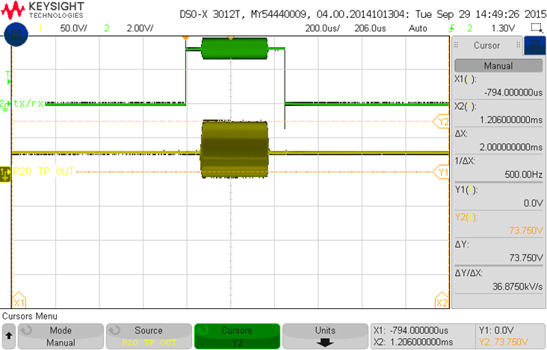

Figure 4. Drain voltage with 30 V supply at 600 Vpp output.

1. **IMPORTANT**: Turn the RF power back down to -20 dBm.
2. If everything is okay, then power off. (RF, 30 V, Front Panel.)
3. Attach 50 V from the Cap board to the Power Amp and the 50 V supply to the Cap board from the PDB.
4. Un-terminate RF-Out and reconnect the RF connector from the high power switch.
5. Terminate Rx on HPSW.
6. Connect dummy load.
7. Connect HIGH VOLTAGE probe to the output Pin **P5** on the filter board.
8. Turn on Front Panel and 3.3 V and then the RF from the signal generator.
9. Go from -20 dBm until you reach 950 Vpp; this will be around 17 dBm.
10. Recheck all drain voltages (Cap side of MOSFET).
11. Drain voltages should be around 120 V @ 950 Vpp on the output filter pin.
    1. The preamp will be much lower than the others.
    2. If above 170 V, replace the MOSFET. (Think about just replacing all the main ones at once if they look close to around 160 V/170 V.)
12. **IMPORTANT**: Turn RF back down to -20 dBm.
13. Power off: RF, then 3.3 V, then Front Panel.
14. Attach RF_IN on PWRAMP and Rx on HPSW (Un-terminate).

# Conclusion

This concludes the work instructions for testing the Power Amplification Board of a SuperDARN transceiver box. The next step in the procedure for Servicing a SuperDARN Transceiver is to test the FPGA Board.